**Overall Architecture:**

|  |  |
| --- | --- |
| **Components** | **Description** |
| General Purpose Registers (GPRs) | 8: R0 – R7 |
| Special Purpose Registers (SPRs) | 7: PC, IR, RA, RB, RZ, RM, RY |
| Memory | RAM: 8 – bit Address Line and 32 – bit Data |
| Instruction Supported | 13 |

**Components:**

1. Processor Pipeline – 5 stage pipeline

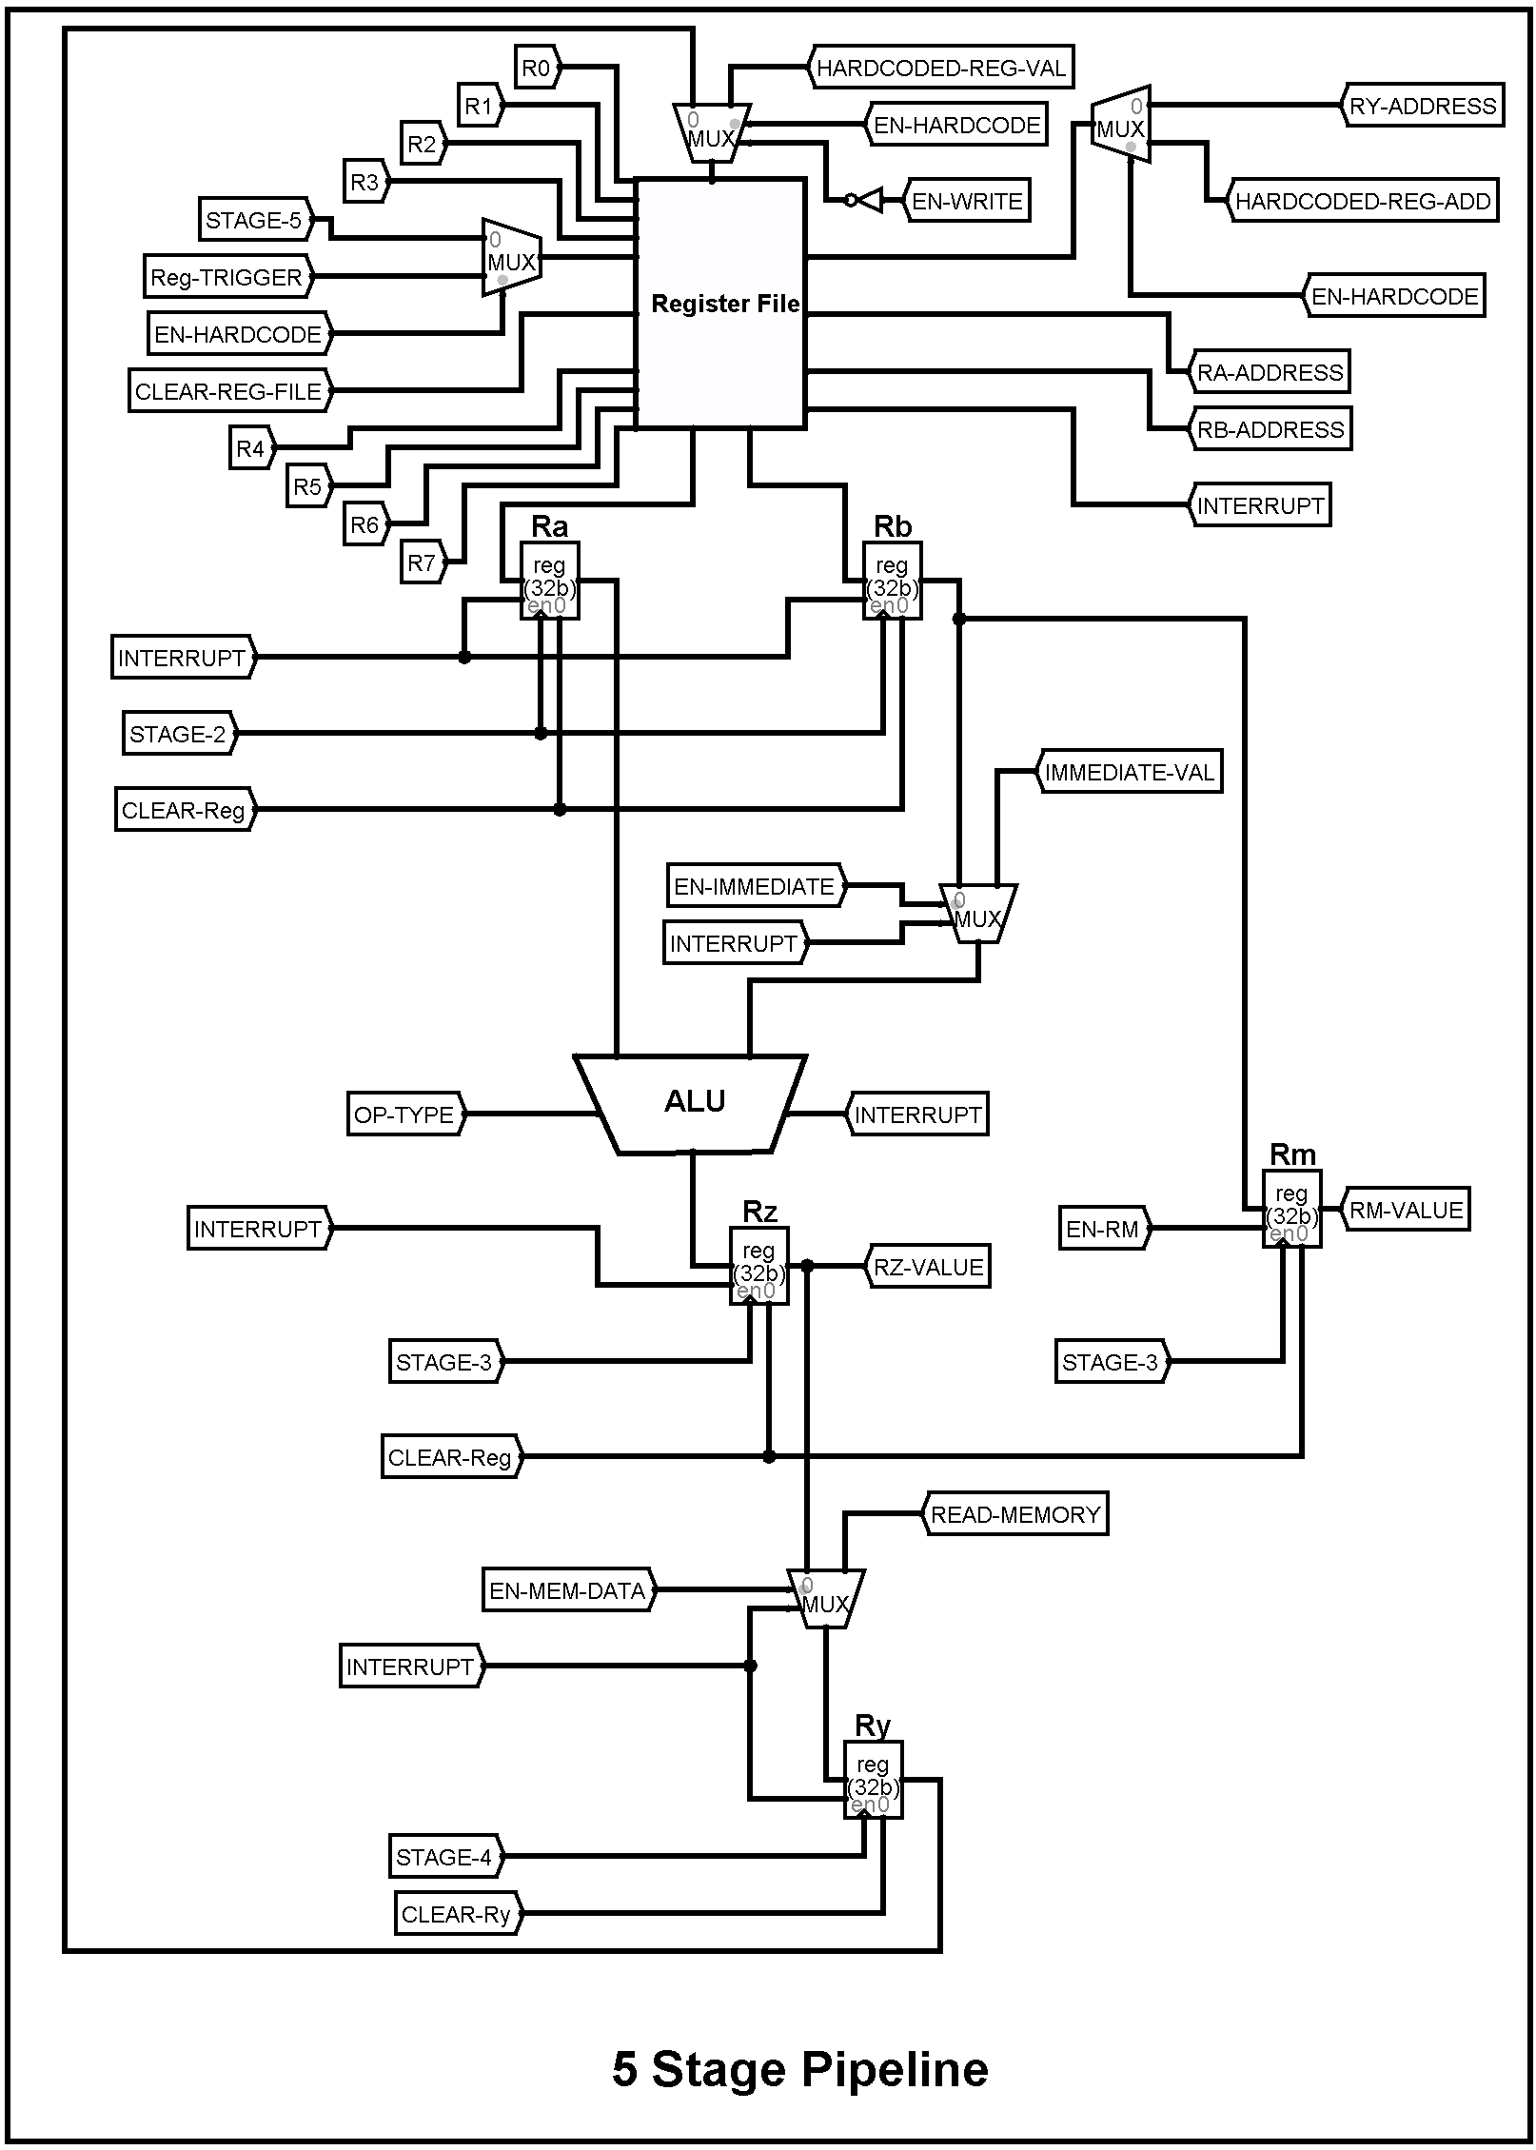

1. Fetch Unit

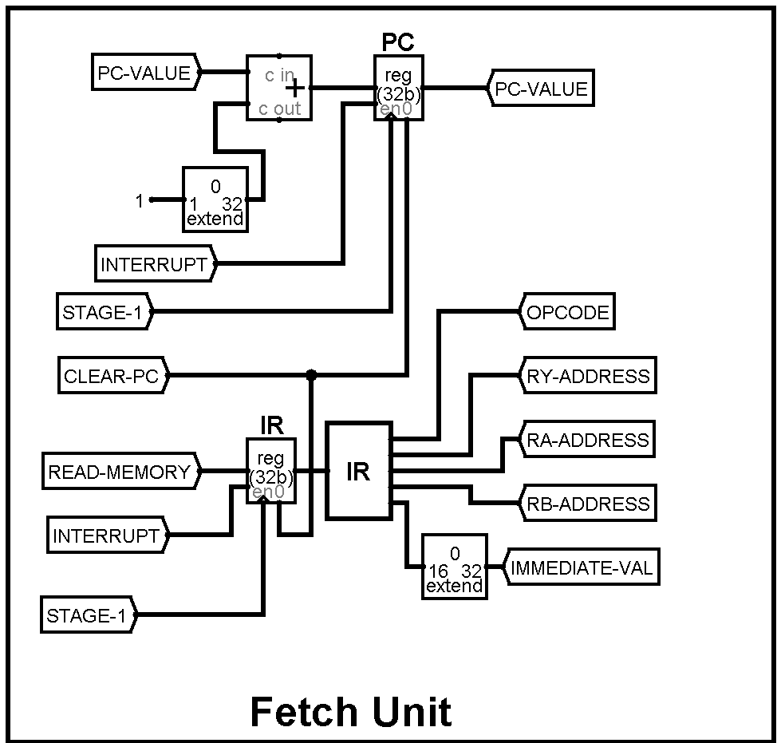

1. Memory Unit

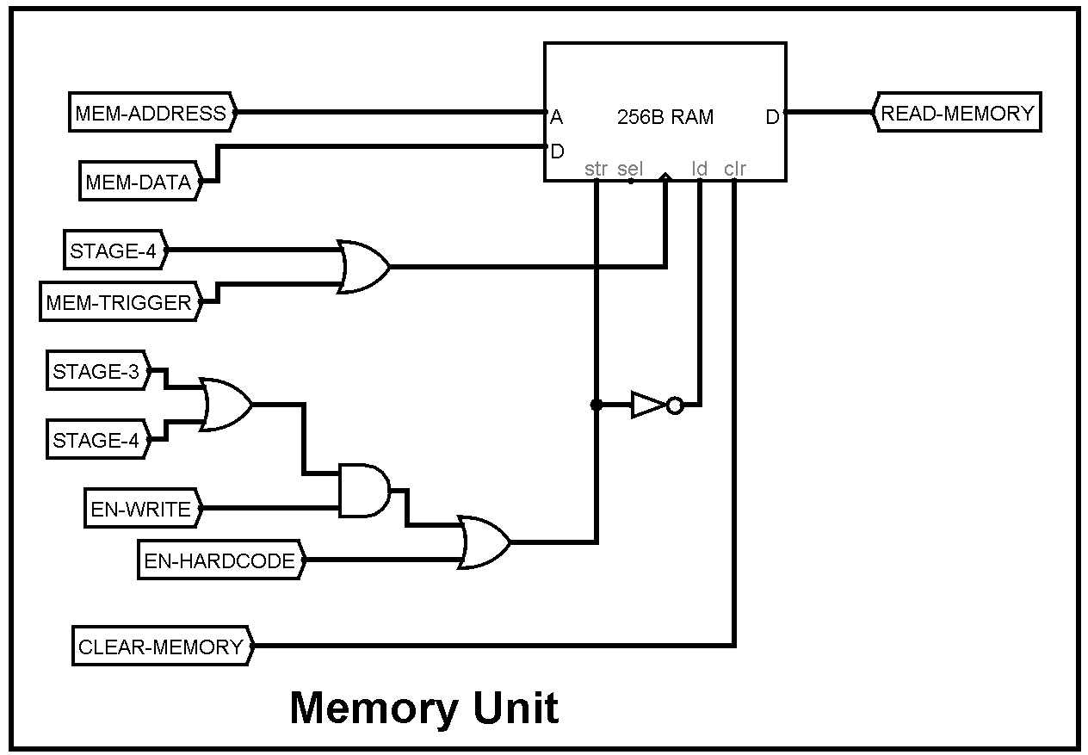

1. Processor Memory Interface

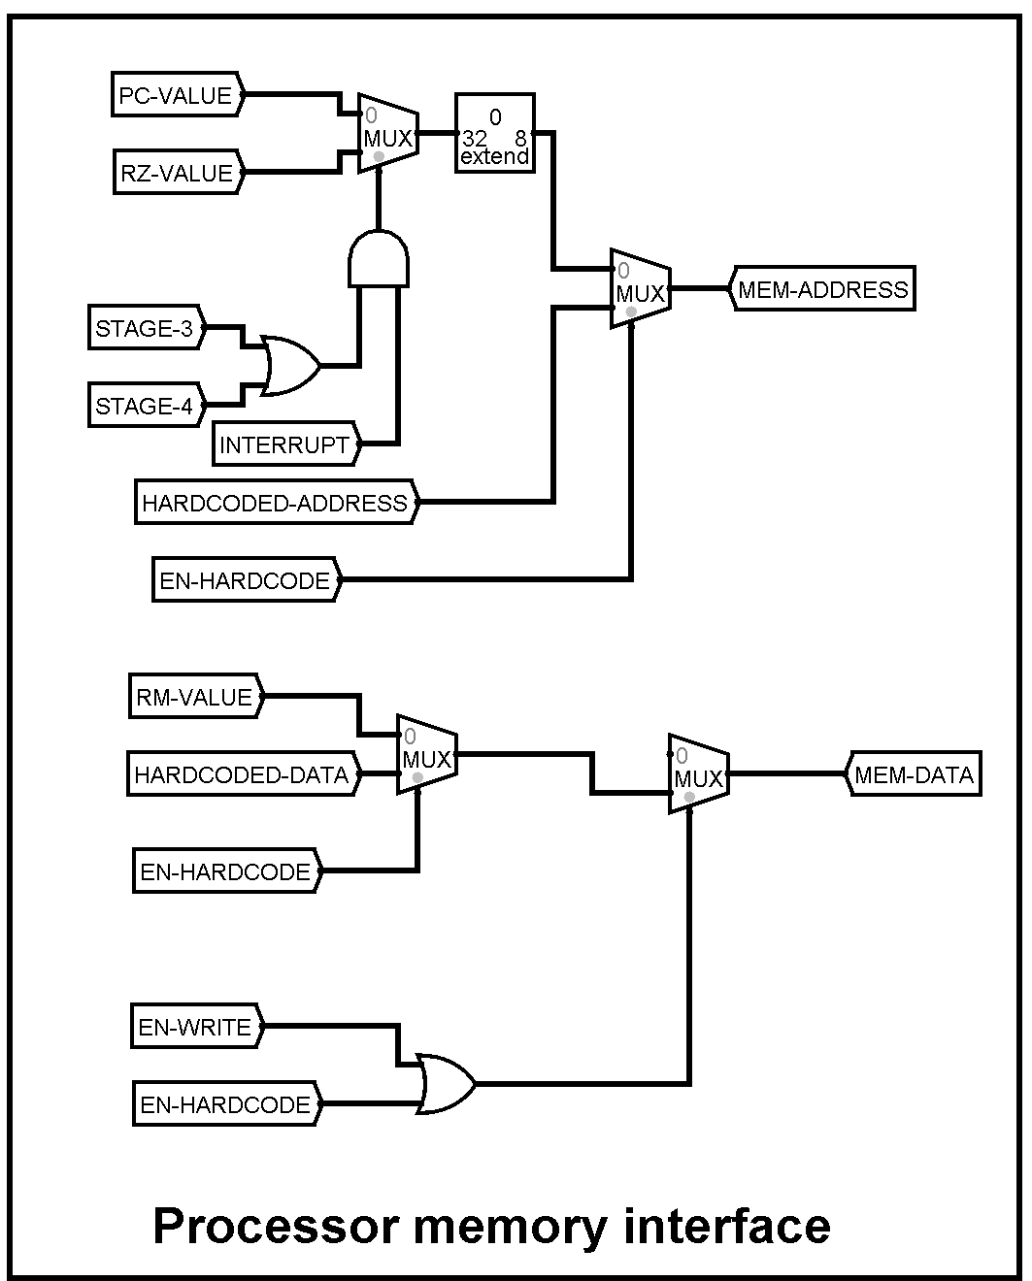

1. Instruction Register – internal circuit

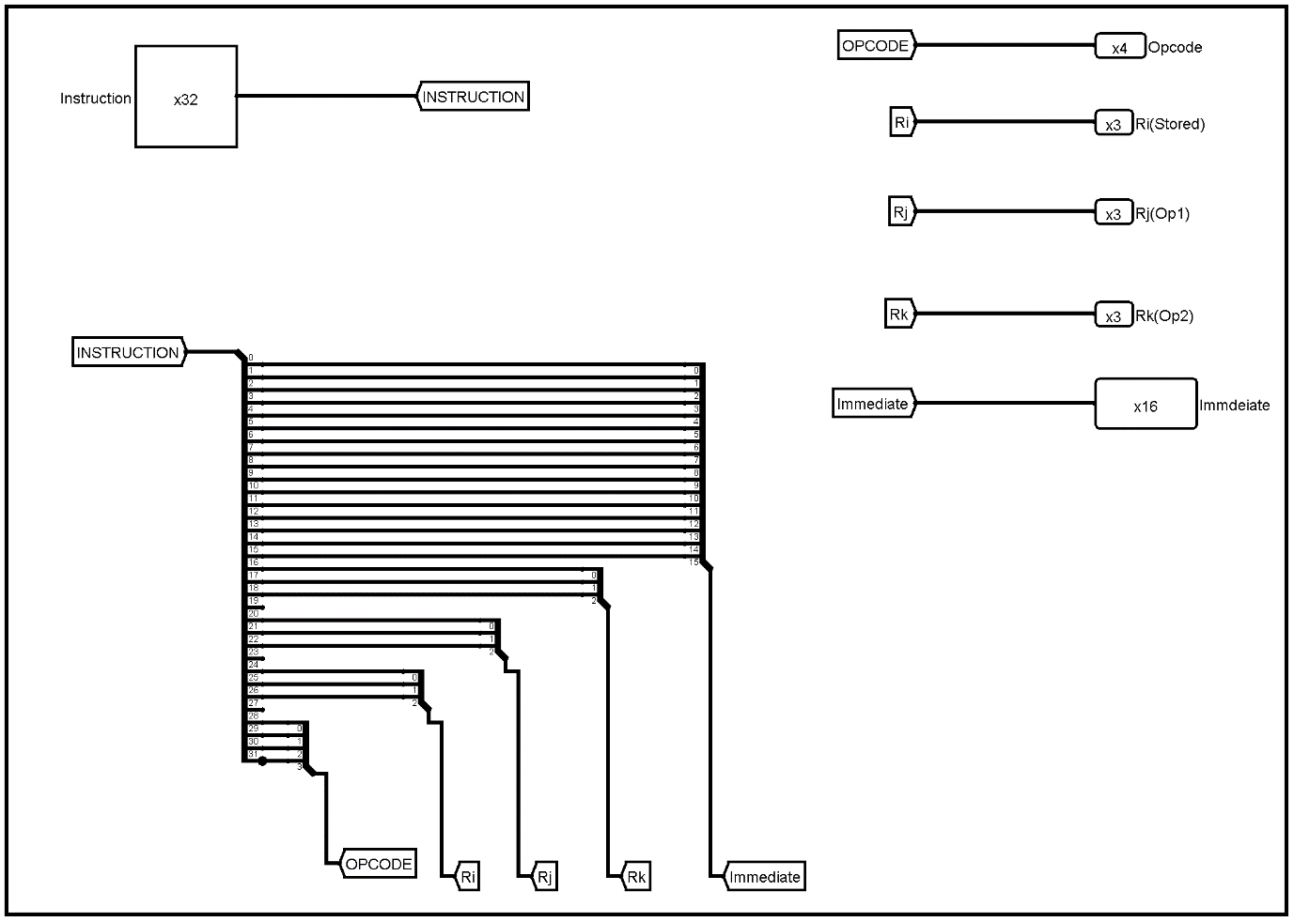

1. Control Unit

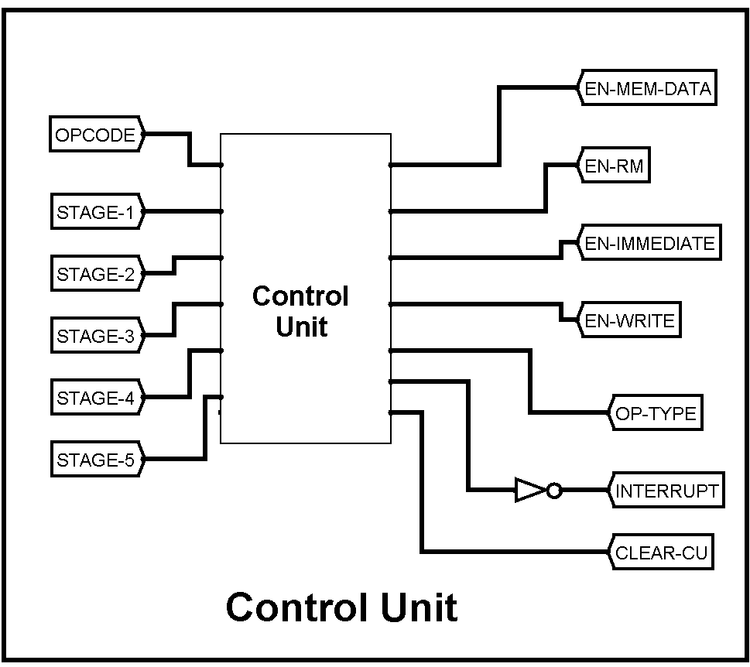

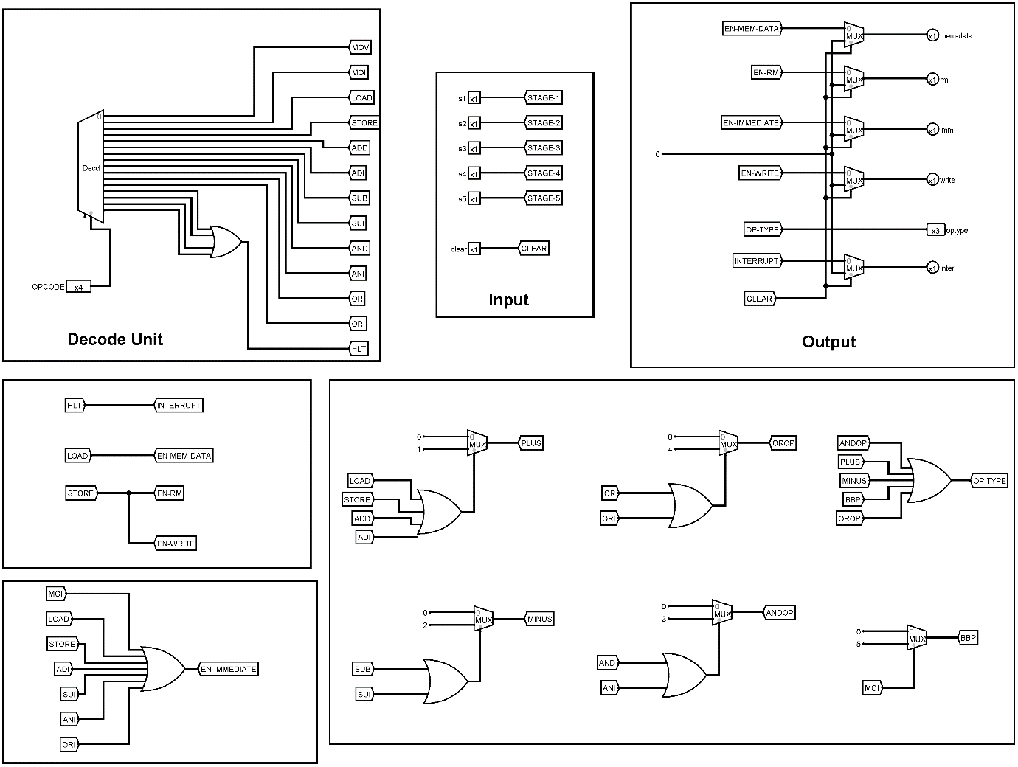

1. Register File

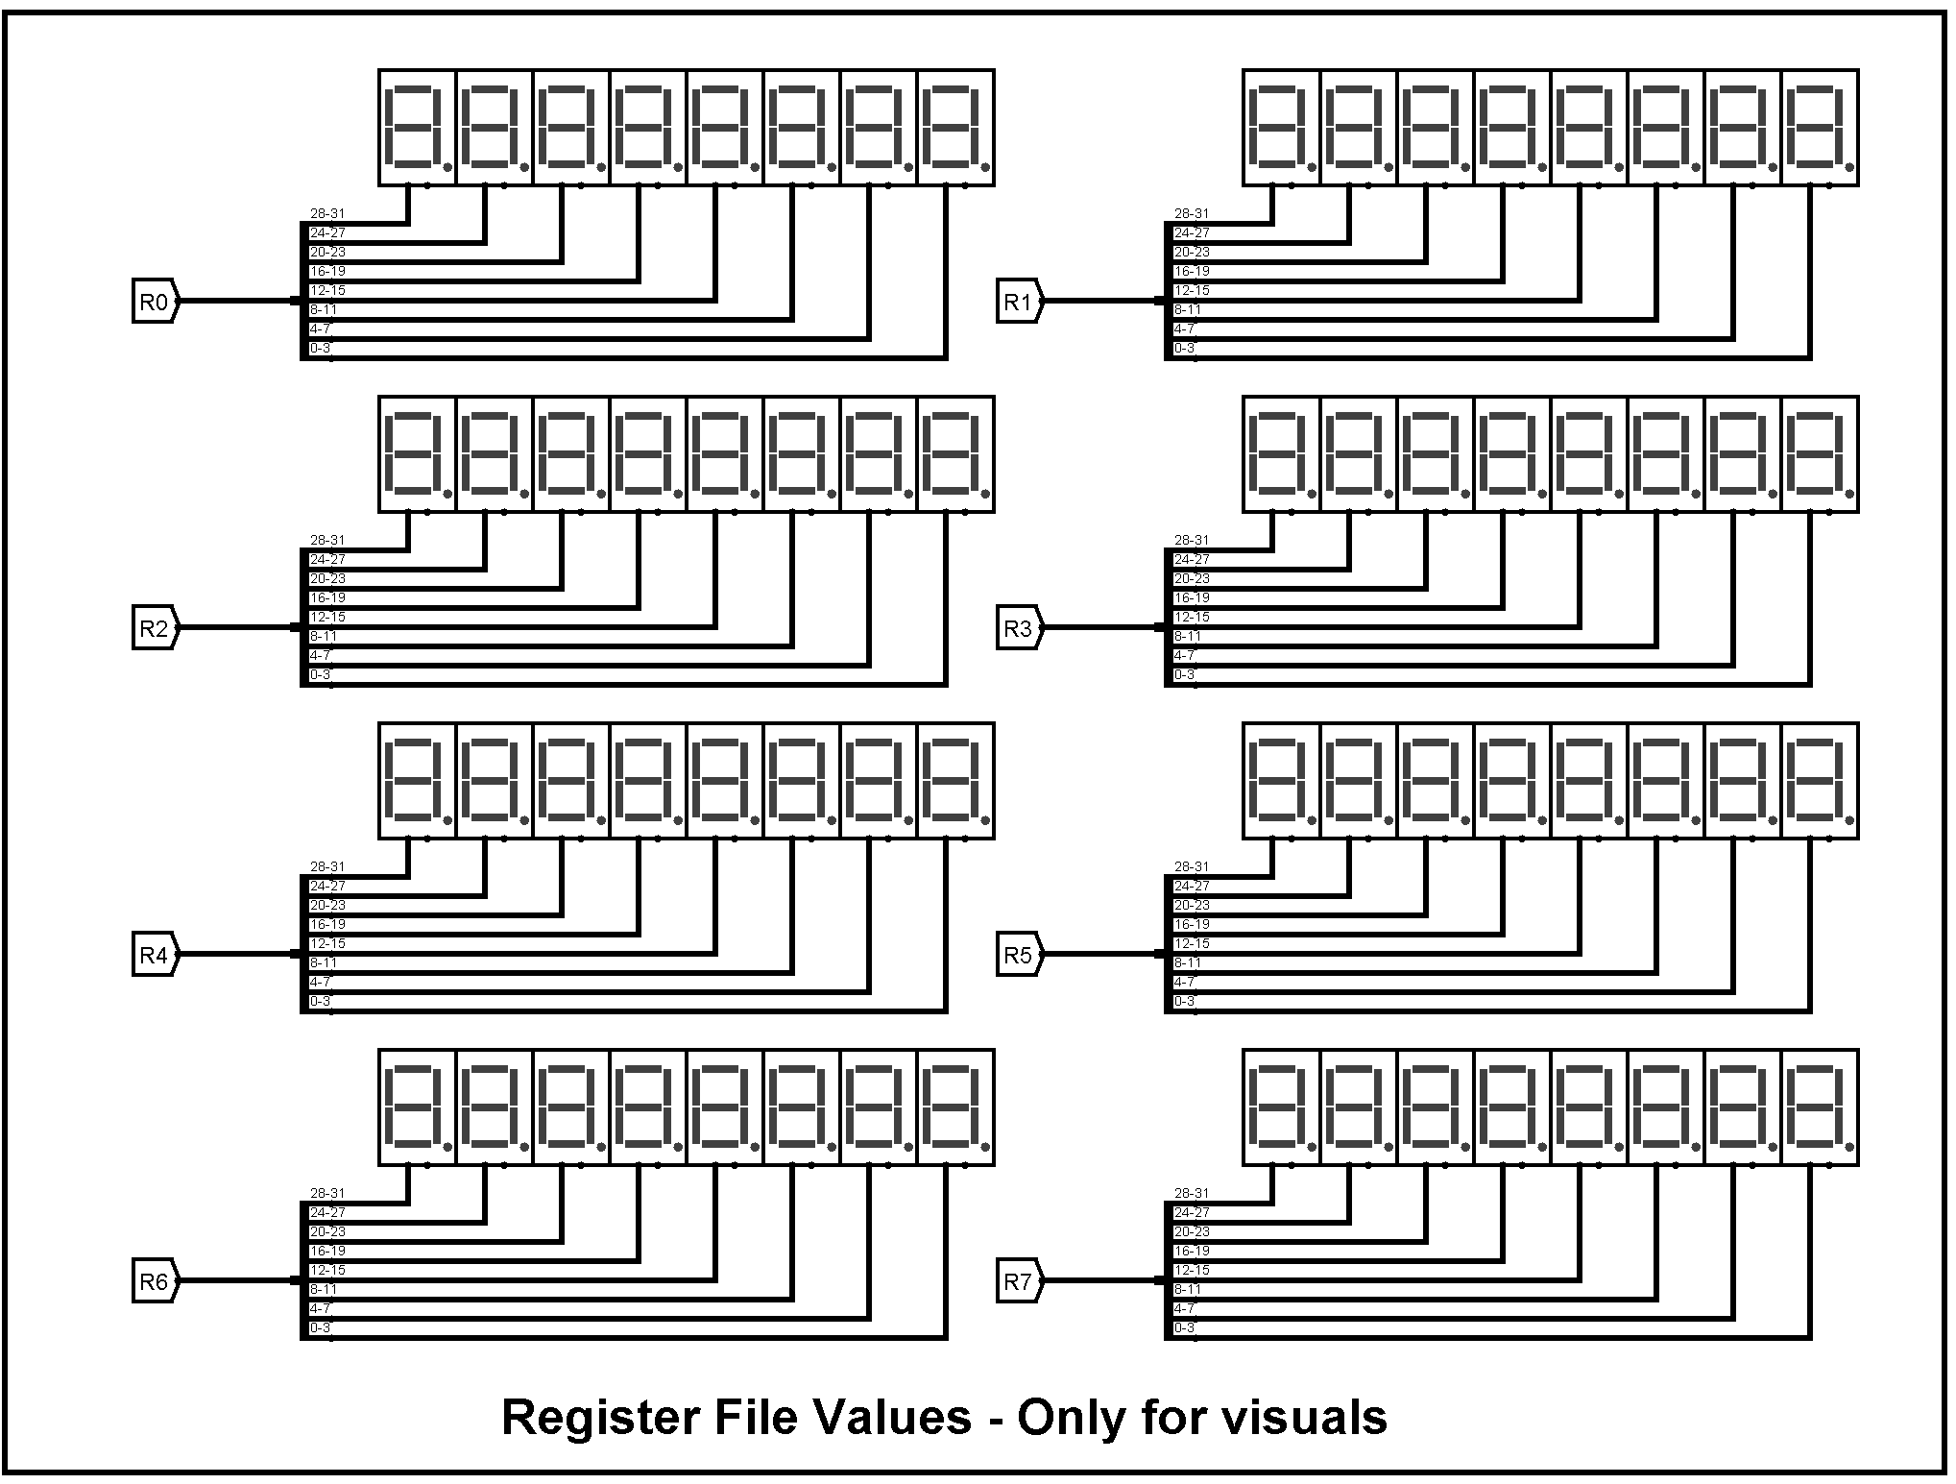

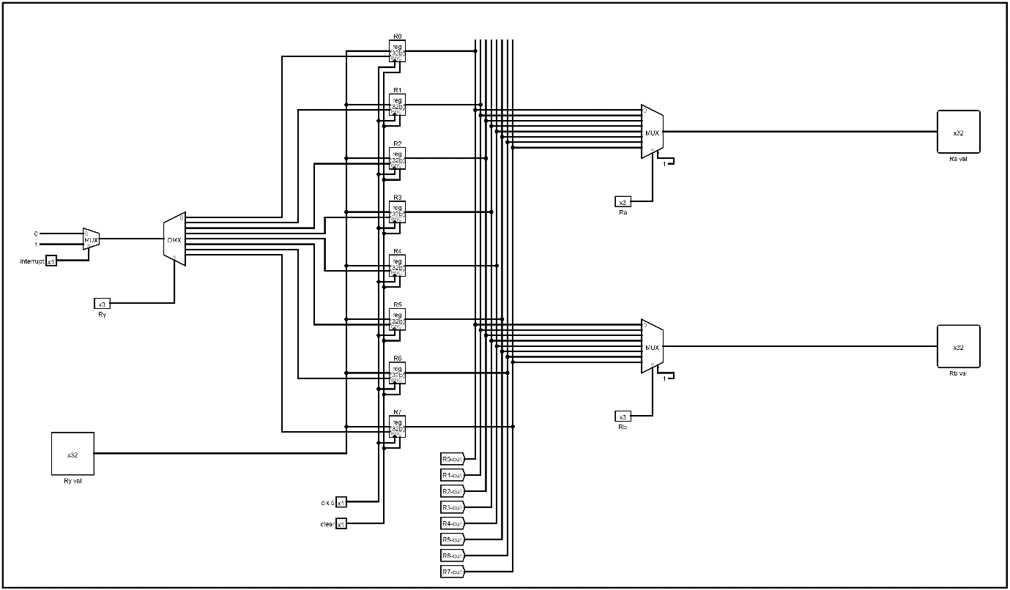

1. ALU – Internal circuit

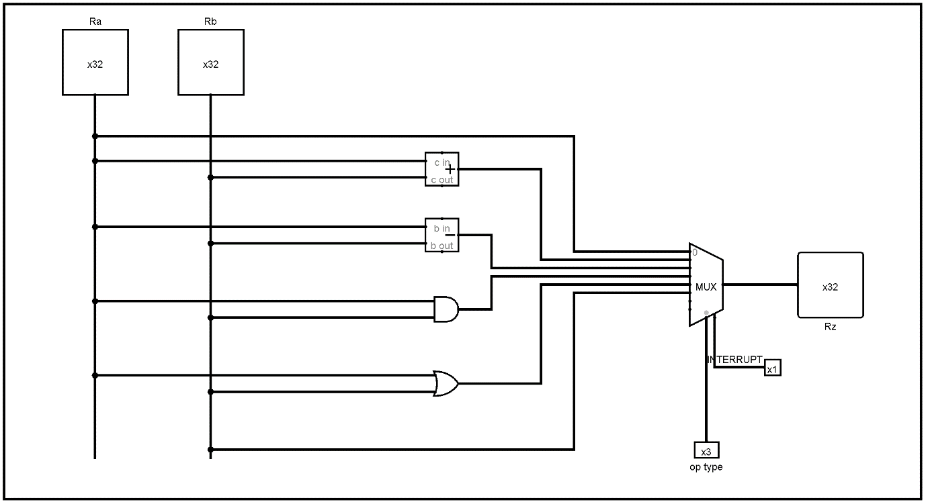

1. Stage Counter

